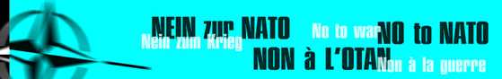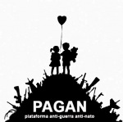

Agenda for the 2010 Action Conference in Portugal and the Preparation of the Counter Summit and Actions against NATO Summit

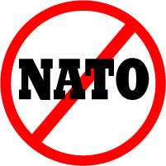

Thursday, October 14th

Evening
Public Events in Lisbon and Porto with Members of the ICC

Friday, October 15th

12.00 (approximately)
Press Conference

14.00-19.00
Meeting of the ICC

19.30
Public Event in Lisbon
Common Dinner of ICC and PAGAN

Saturday, October 16th

10.00
Portugal and NATO (From Colonial War to Afghanistan)

10.00-13.00
Participating in the Cultural Event against NATO

11.30
The Beginning: NATO and the Balkans

13.00-21.00
Action Conference of the ICC / PAGAN

13.00-15.30
Overview Lecture: NATO and EU, Willy Meyer
Where We Stand – Where We Want to Go: Actions during the Counter Summit
Information and Discussion

16.00-20.00
Working Groups, f.e.
Counter Summit Mobilisation
Civil Disobedience
Media Work
Square of Peace

Sunday, October 17th

10.00-13.00
Participation in the Ongoing Event of Cultura with Speakers from the ICC: Arielle Denis and Reiner Braun, from PAGAN: Mario Tomé

13.00-16.00
Action Conference of the ICC/ PAGAN
Information Meeting of the ICC: Where Do We Stand with the Preparation of Anti-Nato Actions

15.00-16.00
Reports and Decisions

16.30
Participation in the Final Event of Cultura Conference: Is there Life Outside NATO?

Registration: Kongress[at]IALANA.de | Contact: Kongress[at]IALANA.de

